# Norfolk Community Biodiversity Awards 2025

## ****The Awards****

**The Norfolk Community Biodiversity Awards celebrate the achievements of individuals and groups who are responding to the call for action for nature and making a real difference to wildlife, places and people in Norfolk. This year there are six Award categories:**

* **Young People's Achievement**
* **Saving Species**
* **Spaces for Nature & Wellbeing**
* **Groups**
* **Rivers and Wetlands (not ponds)**
* **The Richard Waddingham Ponds Award**

The 2025 awards, **run by the Norfolk Biodiversity Partnership (NBP),** will take place at the**Norwich Forum,** on **Saturday, 4th October.** Representatives from all nominees will be invited to attend the ceremony when winners will be presented with framed certificates**.**There will also be the opportunity for nominees to have a public facing stand at the Forum during the day, to promote their work and network with others. Spaces are free but limited, on a ‘first come, first served basis’, so please confirm if the nominee would like to book a space in the final question on this form.

### ****Who can enter****

**Nominations are welcome from (or on behalf of) groups and individuals, and anyone over 16* can be nominated although activities must not be part of any normal paid work for a conservation organisation but can be volunteer work.   
*The 'Young People's Achievement Award' is open to nominees aged 25 and under. If the nominee is below the age of 16, nominations must be made by a parent, guardian or teacher.**

### ****Making your nomination****

**Once completed please send this form to** [**biodiversityawards@norfolk.gov.uk**](mailto:biodiversityawards@norfolk.gov.uk)**.**

**You can nominate yourself or the group you are part of.**

### ****How nominations will be assessed****

**Nominations will be judged against: the extent of biodiversity enhancement; the degree of community involvement; evidence of long-term sustainability (such as site management plans); how they contribute to the development of an ecological network; interpretation; public accessibility; and the extent to which nominees have inspired and motivated others in their community and contributed to new knowledge of Norfolk's biodiversity. We are looking for applications that impart excitement about what has been achieved and may inspire others to take action!  
  
The closing date for nominations is 1st September 2025**

**All fields/sections in the form are mandatory. Incomplete nominations will not be considered.**

**The 2025 Community Biodiversity Fair and Awards are kindly sponsored by**

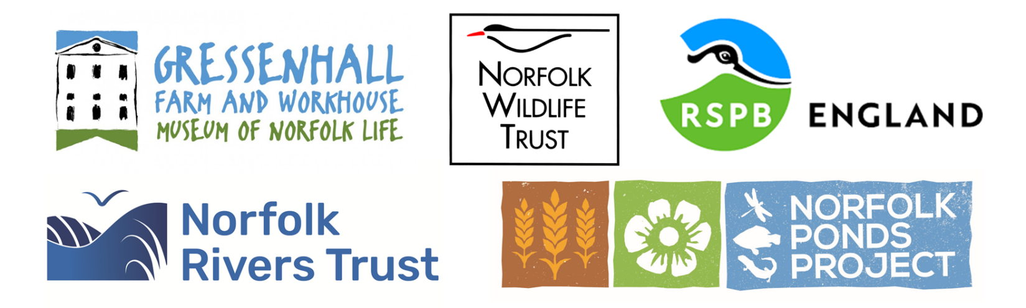

## ****Nomination Form****

**Please** provide the name for the person, group or project nominated and an email address or a phone number.

|  |
| --- |
|  |

|  |  |  |
| --- | --- | --- |
| Please confirm that you have their permission to send us this information | |  | | --- | |  | |

### ****Award Categories****

### **Please select an Award category for your nomination (please select only one). We may contact you if we consider your nomination more appropriate to another category.**

|  |  |  |
| --- | --- | --- |
| |  | | --- | |  | | **Young People's Achievement: This award is for individual young people under 25 whose efforts contribute to recording, understanding or action to benefit nature and biodiversity. Young people hold the key to the future for our wildlife so we are looking for those who are inspirational.**  **Sponsored by Gressenhall Environment Hub** |
| |  | | --- | |  | | **Saving Species: This award recognises individual or group efforts to improve the situation for wildlife species or species groups. With so many species in rapid decline action is needed at every level. We are looking for activities that directly benefit species populations or a specific habitat they rely on.**  **Sponsored by the RSPB** |
| |  | | --- | |  | | **Spaces for Nature & Wellbeing: This award celebrates spaces within communities for nature and people, whether large or small. This might be enhancing existing spaces or creating new ones. Action at a local level, by local people is vital to ensure a brighter future for biodiversity.**  **Sponsored by Norfolk Wildlife Trust** |
| |  | | --- | |  | | **Richard Waddingham Ponds Award: This award commemorates the great work of Richard Waddingham of Manor Farm, Briston, by recognising the achievements of community groups whose voluntary actions make a difference for water, wildlife and people via ponds in Norfolk.**  **Sponsored by The Norfolk Ponds Project** |
| |  | | --- | |  | | **Groups:** This award recognises the achievements of groups working on biodiversity projects in their local community. Local groups inspire people to recognise and care for their local biodiversity and bring people together to work with a common purpose. We are looking for achievements for the group, as well as for wildlife and habitats.  **Sponsored by Norfolk Biodiversity Partnership** |
| |  | | --- | |  | | **Rivers and Wetlands (not ponds)**:  This award celebrates groups or individuals who have inspired people to connect with their local river and wetland ecosystems. We are looking for activities that have helped communities understand the important role of Norfolk’s river catchments in supporting biodiversity.  **Sponsored by Norfolk Rivers Trust** |

## Your contact details

### Contact details of person submitting the nomination

|  |  |  |
| --- | --- | --- |
| Your name | |  | | --- | |  | |
| How do you know the nominee? | |  | | --- | |  | |
| Your telephone number | |  | | --- | |  | |
| Your E-mail address | |  | | --- | |  | |

### Reason for nomination

Overview of the nomination - Please include as a minimum: the name of the activity carried out by the group, project or person and its location and size; the aims and objectives of the activities; how long the activity has been running; how the group, project or person got started on this activity. (Maximum 500 words)

|  |
| --- |
|  |

Please describe what has been achieved and why you think this merits an award. Where relevant please include details about: what has been achieved for biodiversity, how has the community been involved, how many people have been actively involved, how the work will be sustained in the long term, how people can access the project to see what has been achieved, how the activity or nominee is innovative and inspiring and how the activity and its importance has been promoted to the wider community (Maximum 500 words)

|  |
| --- |
|  |

Please list the top 5 skills that the nominee has gained through working for this activity/project (i.e. scrub clearance, coppicing, pond management, hedge laying, community group admin, recruiting new volunteers, walk/educational activities, identifying/recording species, tree planting, communication skills, etc).

|  |
| --- |
|  |

Additional supporting information - where relevant please include: quotes from volunteers and members of the community regarding the nomination, a summary of any evaluations and feedback, website links and links to any blogs and social media activity etc. (Maximum 500 words)

|  |
| --- |
|  |

You may supply up to 3 photos which you agree we can use freely (in this and subsequent years) for promotion of the Awards. Please only submit photos you grant us permission to use and where you have the permission of those photographed. A short video would also be most welcome. Please attach these files to your completed nomination form (or via a files sharing platform) and send them to:[**biodiversityawards@norfolk.gov.uk**](mailto:biodiversityawards@norfolk.gov.uk)

## Declaration

### I confirm that the nominated project/group/individual has been informed of their nomination, and has consented to be considered for a Norfolk Community Biodiversity Award

|  |  |  |
| --- | --- | --- |
| |  | | --- | |  | |  |

Yes

I confirm that the photographs I have supplied can be used freely by the Norfolk Biodiversity Partnership in their promotion of the Norfolk Community Biodiversity Awards or for other biodiversity activities/projects and that I have the consent of any individuals depicted.

|  |  |  |  |
| --- | --- | --- | --- |
|  | |  | | --- | |  | |  |

Yes

Has this activity been supported by a member of paid staff?

|  |
| --- |
|  |

Yes

|  |
| --- |
|  |

No

Please type your name in to confirm that the information provided on this form is accurate to the best of your knowledge.

|  |
| --- |
|  |

### Please ensure that all sections of this form are completed. Incomplete applications will not be considered. We will acknowledge that we have received your nomination within one week of submission. If you haven't heard from us by then, please get in touch directly by email: [biodiversityawards@norfolk.gov.uk](mailto:biodiversityawards@norfolk.gov.uk). We recommend that you print off your completed nomination for your own records.

## Terms and conditions

Before you can make a nomination you must read and agree to the awards’ [terms and conditions](https://norfolkbiodiversity.org/terms/).

|  |
| --- |
|  |

I agree

The Norfolk Biodiversity Partnership will ask for your contact details so that we can contact you regarding your nomination. We will only use this information in relation to the Biodiversity Awards and will keep it secure in line with The General Data Protection Regulation (GDPR) (Regulation (EU) 2016/679), the Data Protection Act 2018 and [Norfolk County Council’s data protection policy and guidelines](https://www.norfolk.gov.uk/article/39306/Data-protection).

|  |
| --- |
|  |

I agree

We would like to use words, photographs or videos submitted within nominations to promote future

Awards or Biodiversity Partnership activities or projects. Please confirm that you agree with this use.

|  |
| --- |
|  |

I agree

### 

Would the nominee be interested in receiving more information about hosting a public facing stand at the daytime event on October 4th? Please note, spaces are on a first come, first served basis.

|  |
| --- |
|  |

Yes

|  |
| --- |
|  |

No